Q1 In which year and on which weekday were the highest average orders recorded?

select top 1 format(order_date,'yyyy')as years,
format(order_Date,'dddd') as weekday ,
count(order_date) as total_orders
from orders
group by
format(order_date,'yyyy'),
format(order_Date,'dddd')
order by total_orders desc;

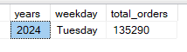

Q2 GENDER WISE TOTAL COMPLETED ORDERS IN All YEARS ?
SELECT * FROM (SELECT A.GENDER,DATEPART(YEAR,B.ORDER_DATE) AS YEARS,
COUNT(B.ORDER_DATE) AS COMPLETED_ORDERS
FROM CUSTOMERS A
INNER JOIN ORDERS B
ON (A.CUSTOMER_ID = B.CUSTOMER_ID)
GROUP BY A.GENDER,DATEPART(YEAR,B.ORDER_DATE)) AS SUBQRY
PIVOT (
SUM(COMPLETED_ORDERS)
FOR GENDER
IN (MALE,FEMALE)) AS PTABLE;
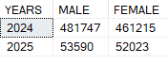
Q3 MONTHLY WISE TOTAL COMPLETED ORDERS ON YEARLY BASIS.

WITH COMPLETED AS
(SELECT CONCAT('Qtr',DATEPART(QUARTER,ORDER_DATE)) AS QTR,
YEAR(ORDER_DATE) AS YEARS,COUNT(ORDER_DATE) AS COMPLETED_ORDERS
FROM ORDERS
WHERE ORDER_STATUS='COMPLETED'
GROUP BY YEAR(ORDER_DATE),DATEPART(QUARTER,ORDER_DATE)),
CANCELLED AS
(SELECT CONCAT('Qtr',DATEPART(QUARTER,ORDER_DATE)) AS QTR,
YEAR(ORDER_DATE) AS YEARS,COUNT(ORDER_DATE) AS CANCELLED_ORDERS
FROM ORDERS
WHERE ORDER_STATUS='CANCELLED'
GROUP BY YEAR(ORDER_DATE),DATEPART(QUARTER,ORDER_DATE)),
PENDING AS
(SELECT CONCAT('Qtr',DATEPART(QUARTER,ORDER_DATE)) AS QTR,
YEAR(ORDER_DATE) AS YEARS,COUNT(ORDER_DATE) AS PENDING_ORDERS
FROM ORDERS
WHERE ORDER_STATUS='PENDING'
GROUP BY YEAR(ORDER_DATE),DATEPART(QUARTER,ORDER_DATE))
SELECT A.QTR, B.YEARS,A.COMPLETED_ORDERS,
B.CANCELLED_ORDERS, C.PENDING_ORDERS
FROM COMPLETED A
LEFT JOIN CANCELLED B ON A.YEARS=B.YEARS AND A.QTR=B.QTR
LEFT JOIN PENDING C ON A.YEARS=C.YEARS AND A.QTR=C.QTR
ORDER BY YEARS ASC,QTR ASC;

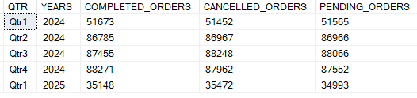
Q4-TOP 5 RESTURANTS WITH HIGHEST REVENUE ?

SELECT TOP 5 A.RESTAURANT_NAME,SUM(B.TOTAL_AMOUNT) AS TOTAL_REVENUE
FROM RESTAURANTS A
INNER JOIN ORDERS B
ON (A.RESTAURANT_ID=B.RESTAURANT_ID)
GROUP BY A.RESTAURANT_NAME
ORDER BY TOTAL_REVENUE DESC;

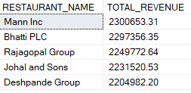
Q5 TOP 5 CUISINE WHICH HAVE RECEIVED THE HIGHEST NUMBER OF ORDERS ?

SELECT TOP 5 ORDER_ITEM,COUNT(ORDER_STATUS) AS TOTAL_ORDER
FROM ORDERS
WHERE ORDER_STATUS='COMPLETED'
GROUP BY ORDER_ITEM
ORDER BY TOTAL_ORDER DESC;

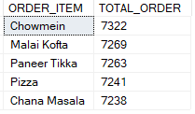

Q6 Which 5 riders have DELIVERED THE MOST?

SELECT TOP 5 A.RIDER_NAME, COUNT(B.DELIVERY_STATUS) AS TOTAL_DELIVERY
FROM RIDERS A
INNER JOIN DELIVERIES B
ON (A.RIDER_ID=B.RIDER_ID)
WHERE DELIVERY_STATUS='DELIVERED'
GROUP BY A.RIDER_NAME;

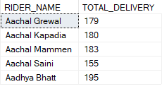
Q7 FASTEST RIDERS: WHICH 5 RIDERS HAVE THE LOWEST AVERAGE DELIVERY TIME?

SELECT TOP 5 A.RIDER_NAME,CAST(DATEADD(SECOND,
AVG(CAST(DATEDIFF(SECOND,'00:00:00',B.DELIVERY_TIME) AS BIGINT))
,'00:00:00') AS TIME(0)) AS AVG_TIME
FROM RIDERS A
INNER JOIN DELIVERIES B
ON(A.RIDER_ID=B.RIDER_ID)
WHERE B.DELIVERY_STATUS='DELIVERED'
GROUP BY A.RIDER_NAME
ORDER BY AVG_TIME ASC;

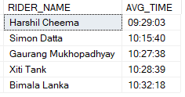
Q8 DELIVERY TIME TRENDS: DURING WHICH TIME SLOT (MORNING, AFTERNOON, EVENING, NIGHT) IS THE DELIVERY TIME THE SHORTEST?
WITH TIMING AS
(SELECT DELIVERY_TIME,
CASE
WHEN DATEPART(HOUR, DELIVERY_TIME) BETWEEN 4 AND 11 THEN 'MORNING'
WHEN DATEPART(HOUR, DELIVERY_TIME) BETWEEN 12 AND 16 THEN 'AFTERNOON'
WHEN DATEPART(HOUR, DELIVERY_TIME) BETWEEN 17 AND 19 THEN 'EVENING'
ELSE 'NIGHT'
END AS TIMECATEGORY
FROM DELIVERIES)
SELECT AVG(DATEPART(HOUR,DELIVERY_TIME))AS AVG_TIME,TIMECATEGORY
FROM TIMING
GROUP BY TIMECATEGORY
ORDER BY AVG_TIME ASC;

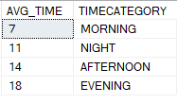
Q9 ORDER CANCELLATIONS: TOP THREE RESTAURANT HAS THE HIGHEST NUMBER OF CANCELED ORDERS?

SELECT TOP 3 A.RESTAURANT_NAME
FROM RESTAURANTS A
INNER JOIN ORDERS B
ON A.RESTAURANT_ID=B.RESTAURANT_ID
AND B.ORDER_STATUS='CANCELLED'
GROUP BY A.RESTAURANT_NAME
ORDER BY COUNT(B.ORDER_STATUS) DESC;

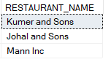
Q10 PERCENRAGE OF DIFFERENT ORDER STATUS IN TOTAL ORDERS

DECLARE @TOTAL_AMT DECIMAL(18, 2)
SELECT @TOTAL_AMT = SUM(TOTAL_AMOUNT) FROM ORDERS
SELECT ORDER_STATUS, SUM(TOTAL_AMOUNT) AS REVENUE,
CONCAT(CAST(CAST((SUM(TOTAL_AMOUNT) * 100.0 / @TOTAL_AMT) AS DECIMAL(10,2)) AS VARCHAR(10)),'%') AS CONTRIBUTION
FROM ORDERS
GROUP BY ORDER_STATUS;

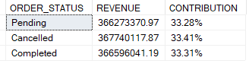
Q11 YEARLY QUARTRWISE CUMULATIVE REVENUE

SELECT YEARS,QTR,ROUND((SUM(REVENUE) OVER(ORDER BY YEARS ASC,QTR ASC)),0) AS CUMULATIVE_REVENUE FROM(SELECT DATEPART(YEAR,ORDER_DATE) AS YEARS,
CONCAT('QTR',DATEPART(QUARTER,ORDER_DATE)) AS QTR,
SUM(TOTAL_AMOUNT) AS REVENUE
FROM ORDERS
GROUP BY DATEPART(YEAR,ORDER_DATE),
DATEPART(QUARTER,ORDER_DATE)
) AS SUB
ORDER BY YEARS,QTR;
